Windows installation guide mflab
Jeroen Castelijns, 26 January 2010

- Download the SVN program Tortoise at http://tortoisesvn.tigris.org/
- Install the program and restart your PC.
- Open the Explorer and browse to the directory where you want to install mflab.
- Inside the directory right click with the mouse and select “SVN Checkout…” (fig.1).

Fig. 1: SVN checkout.

- In de popup (fig.2) fill in the source URL. You can find the most recent source URL on http://code.google.com/p/mflab/source/checkout .
- Leave the other settings on default and click ok.

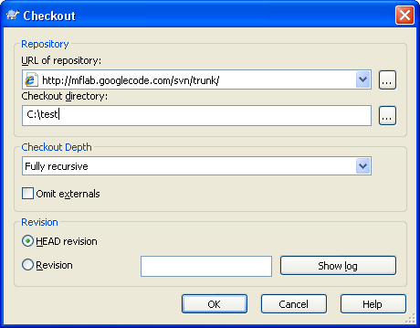
Fig. 2: source URL
- Now the necessary packages for mflab will be downloaded, after it is finished your directory will look like fig.3
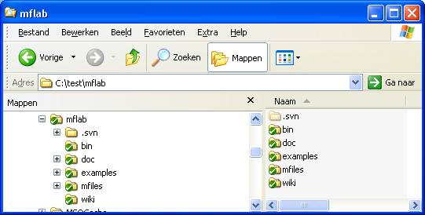
Fig. 3: mflab directory

- For further instructions to get mflab working with Matlab see the User Guide at http://code.google.com/p/mflab/downloads/list .

Common Problems

Q: Tortoise won’t download the files and gives me back the error in fig. 4 ?
A: Your PC is probably inside a corporate network which uses a Proxy Server to connect to the internet. You can enable the Proxy Server at the settings screen (Program Files- > TortoiseSVN -> Settings ) (fig.5). The Proxy Settings are different for each company. Your companies ICT-desk can provide you the right settings.

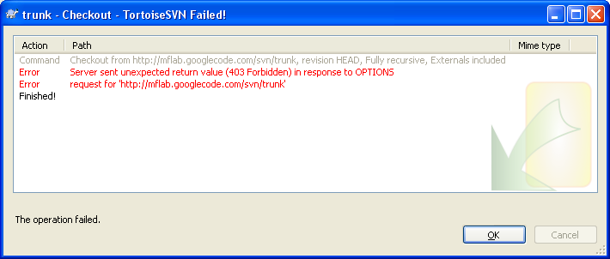
Fig. 4: error Tortoise

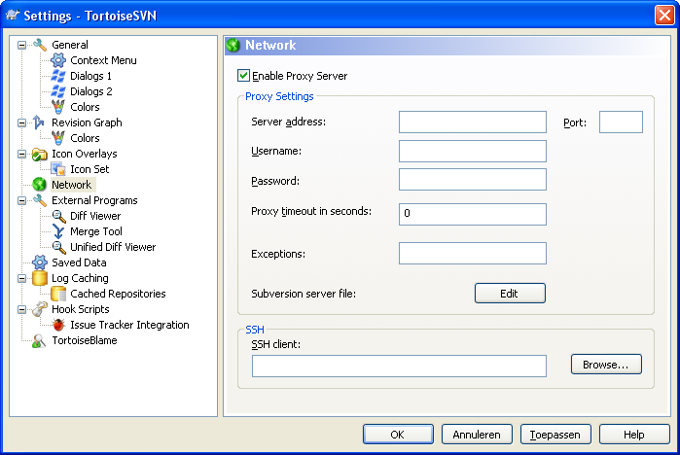
Fig. 5: Proxy Server settings

